Geethanjali College of Engineering and Technology
Freshman Engineering Department
Department of Mathematics
Report on Short Term Training Program (STTP)
On
Role of Statistics in Machine Learning and Data Science
Sponsored by
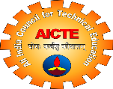AICTE, UGC – HRDC, JNTUH, Hyderabad. 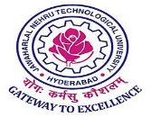
Dated: 29-11-2021 to 04-12-2021

A six-day Short Term Training Program (STTP) on “Role of Statistics in Machine Learning and Data Science” sponsored by AICTE and UGC-HRDC, JNTUH is organized by Geethanjali College of Engineering and Technology, Cheeryal(V), Keesara (M), Hyderabad through Online Web Ex Platform from 29.11.2021 to 04.12.2021. There were four sessions everyday, addressed by Resource Persons who were selected from the IITs/NITs/HCU/OU and other reputed academic institutions and software industries. Every day the session began at 10.00 AM and finished by 05: 15 PM. 90 Participants were registered for this training program.
The training was intended to provide preparedness on the Role of Statistics in Machine Learning (ML) and Data Science. This forum created a platform for exchanging the ideas and share the knowledge on current challenges / issues in the real world in the emerging area of Statistics for Data Science and Machine learning.
The STTP was inaugurated by Dr. G.K. Vishwanadh, (Director, UGC-HRDC, JNTUH, Hyderabad). During the six days of the training, various topics like, Introduction to the Role of Statistics in Data Science and Machine Learning and its implementation, Introduction to Probability Theory, Descriptive Statistics, Predictive Analysis, Distribution Theory, Testing of Hypothesis, Algorithms of Machine Learnings were explained to the participants through presentations and hands-on practical sessions with R programming.

Day wise & Session wise report :
Day-1:
The program was inaugurated by Dr G.K. Vishwanadh, Director,UGC-HRDC,JNTUH. Sir addressed the gathering on current technologies and their need to update ourselves. Dr V.S. Triveni, the Co-ordinator, Geethanjali College of Engineering and Technology, Hyderabad, greeted the dignitaries and participants. Later she explained the importance of the course in the present scenario and its major role in the said area.
During the first day first session Dr V.S.Triveni delivered a talk on the key concepts of statistics in Data Science and Machine Learning and its applications. She emphasised on the demand of the course Data science and its future market.
On Day one, session two, Mr. M. Naveen Vamshi, Technical Consultant, Virtusa, Hyderabad delivered a lecture on “Implementation of Statistics in Machine Learning” and he explained the basic concepts of statistics.
On Day one, session three was addressed by Dr. M. Venugopal, Data Scientist, Juxt-Smart Mandate, Hyderabad on “Role of Statistics in Data Science”. He explained the topic in detail with live examples. Apart from that he gave the gist on new technologies.
On Day one, session four, Dr. Sampath Lonka, Sri Sathya Sai Institute of Higher Learning, Karnataka, delivered a lecture on “Classification Models in ML”.
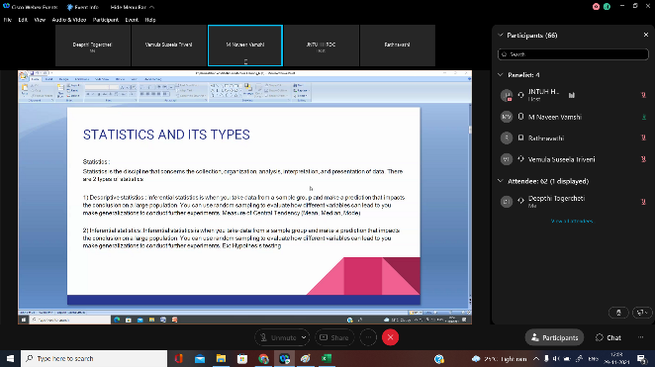 | 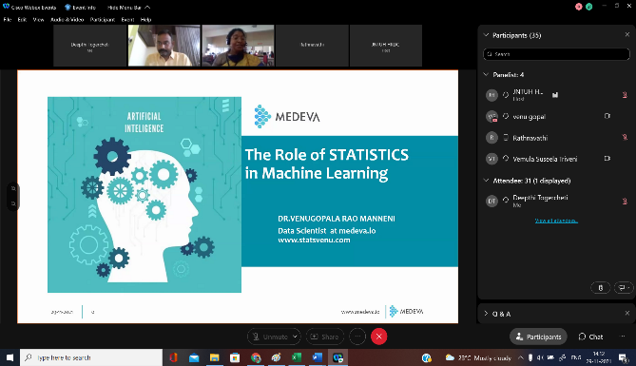
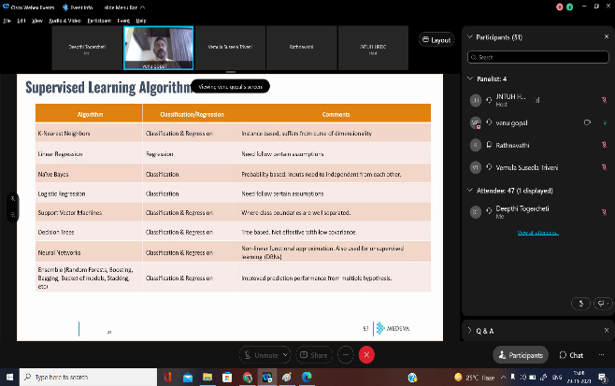 | 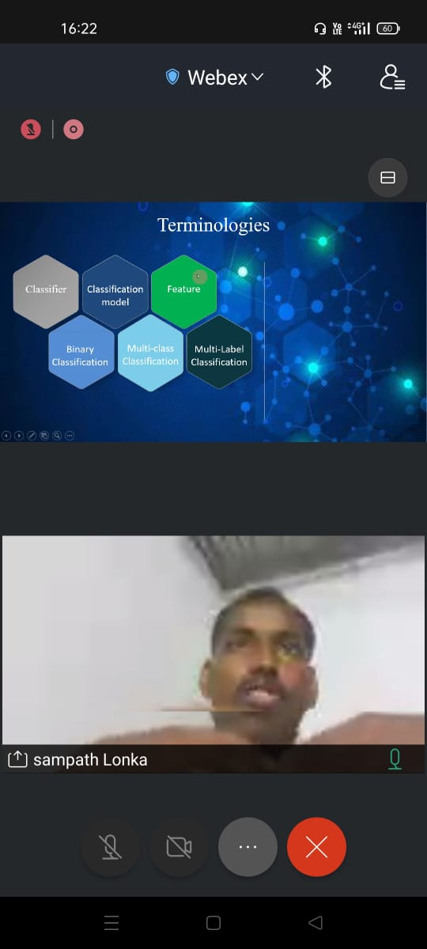

Day-2:

Session one, Dr. Nagendra Kumar Suryadevara, University of Hyderabad gave lecture on “Exploratory Data Analysis using Descriptive Statistics”. Speaker had explained the basic concepts of Descriptive Statistics and explained clearly how to analyse the data using R Tool
Session two was on the topic “Introduction to Probability Theory” delivered by Dr. Manjula S Dalabanjan, Don Bosco Institute of Technology, Bangalore. She gave a brief introduction to Probability with real time examples and extended the topic to Inequalities, Moments and Central Limit Theorem and its applications in Machine Learning.
Session three and four were handled by Mr. J. Uma Mahesh, JRF, NIT, Roorkela. He gave a a practical hands on training session on “Introduction to R Programming”. And explained the basic concepts in R Studio and its packages.
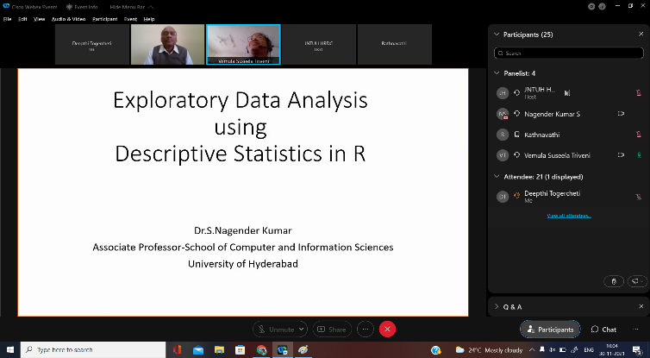 | 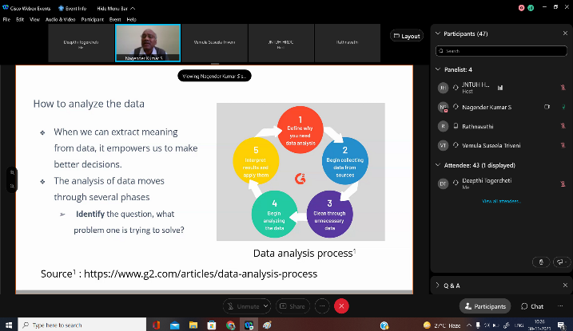
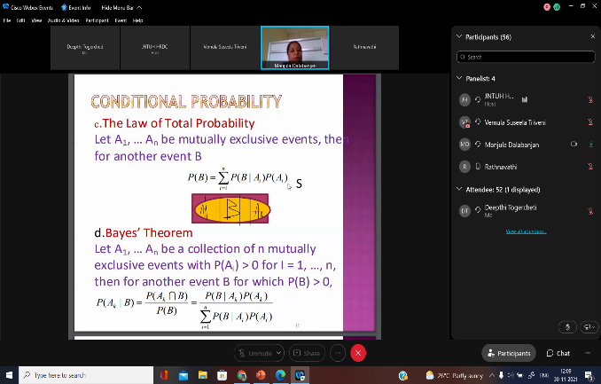 | 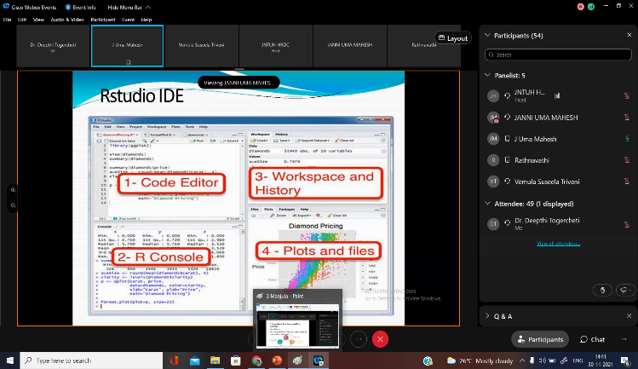

Day-3:

On Sessin one Dr. Ameen Saheb Shaik, B.V. Raju Inst. of Technology, Narspur, gave a talk on theoretical concepts of “Distribution Theory”. The speaker started his session with examples on statistics in Machine Learning and also explained the various distributions and its applications.
Session two was addressed by academician, Dr. B. G. Manjunath, University of Hyderabad, on the topic “Parameter Estimation”.
Session three was hands on training session on “Descriptive Statistics using R” by Dr. T. Deepthi, Geethanjali College of Engineering and Technology, Hyderabad. She explained the basic concepts of Descriptive Statistics i.e Data, Variables and its types, Measures of Central Tendency, Measures of Dispersion, Moments, Skewness and Kurtosis
Session four was on “Machine Learning Techniques: Association Rules” by V. Aditya Srinivas, IT Analyst, Tata Consultancy Services, Hyderabad. During his session he discussed various algorithms in Machine learning along with R programming.
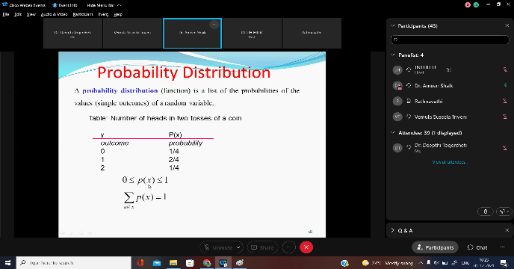 | 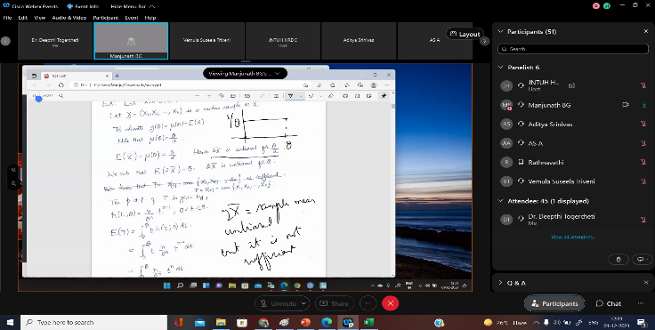
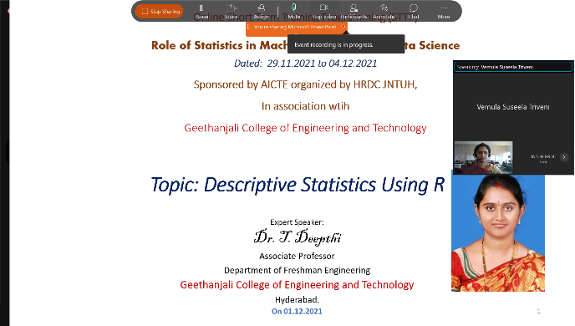 | 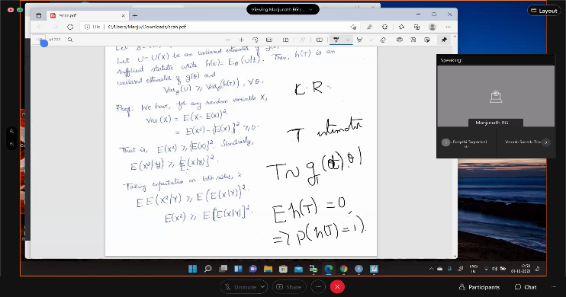

Day-4

Session one was dealt by Dr. B. G. Manjunath, University of Hyderabad , on the topic “Testing of Hypothesis” . He gave a lecture on theoretical and practical concepts of testing of hypothesis using R programming.
Session two and three were handled by by Dr. Sathya Prakash Singh, IIT, Kanpur on the theory of “Predictive Analysis” and hands on training session by using R.
Session four was on hands on practical approach “Data Simulation and Testing using R” by Dr. Ameen Saheb Shaik, B.V. Raju Inst. of Technology, Narspur.

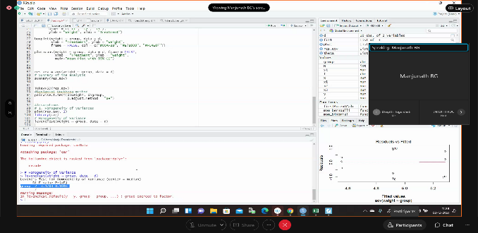 | 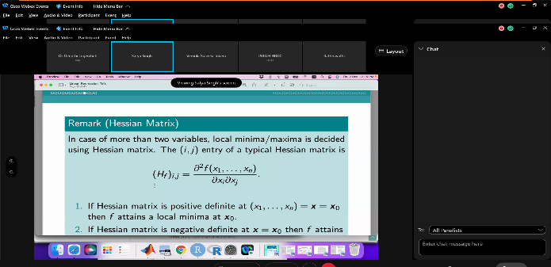
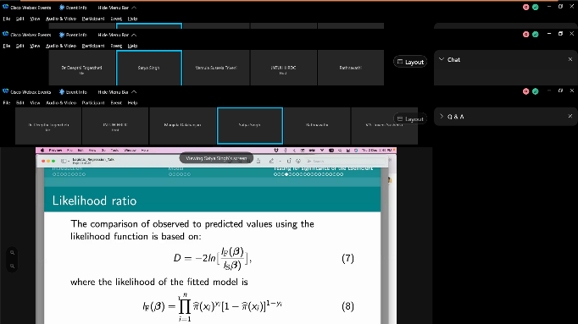 | 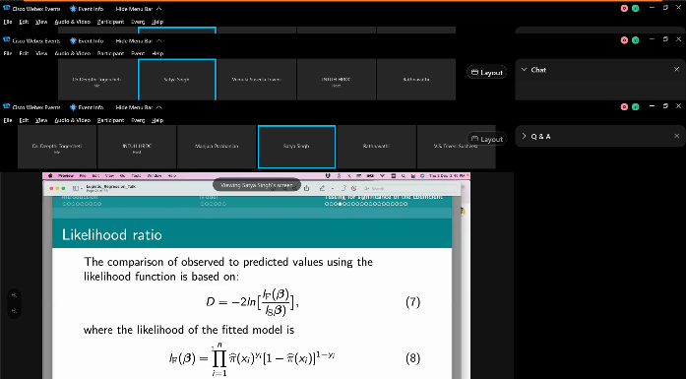

Day-5:

Session one was carried on the theoretical part of “Dimensionality Reduction” by Dr. N.Ch. Bhatra Charyulu, HOD, Department of Statistics, Osmania University, Hyderabad.
Session two was practical session on “Dimensionality Reduction Techniques in R” by Dr. M. Raghunadh Acharya, Hindi Mahavidyalaya College, Hyderabad.
Session three was hands on training session on “Graphical Representation using R” by Dr. Ajantha Rudhra, Geethanjali College of Engineering and Technology, Hyderabad.
Session four focused on theory part of “Kernel Methods” that plays an important role in machine learning by Dr. N.Ch. Bhatra Charyulu, HOD, Department of Statistics, Osmania University, Hyderabad.
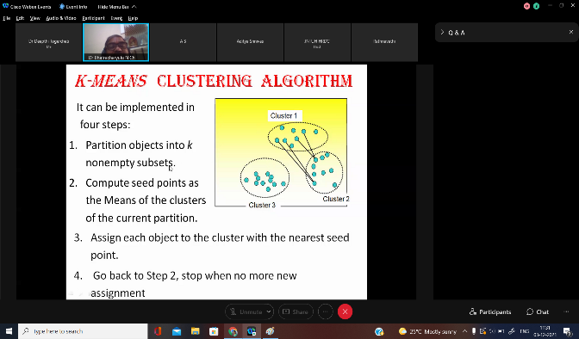 | 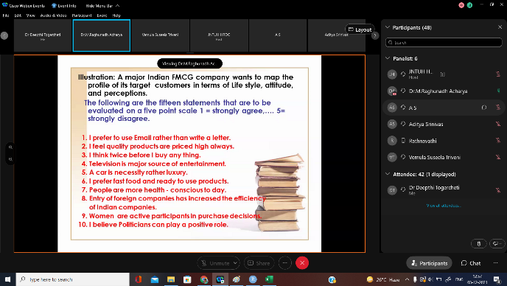
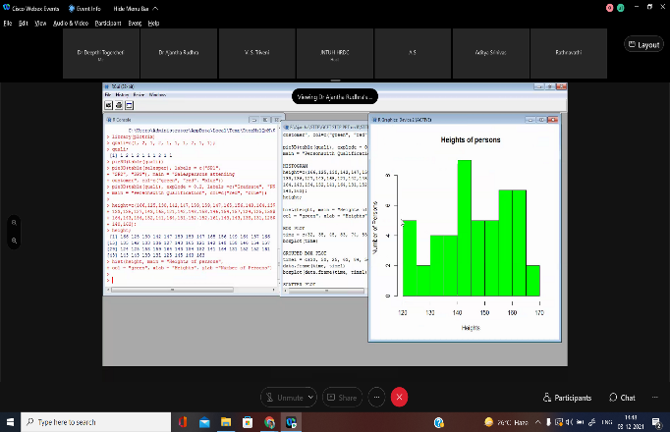 | 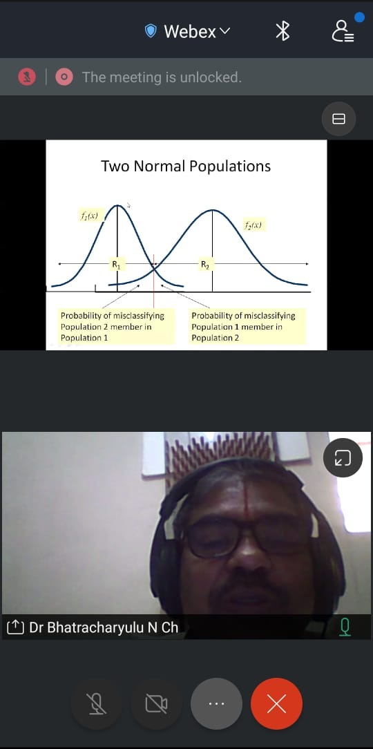

Day-6:
Session one, a practical session was on “Kernel Methods using R” by Dr. M. Raghunadh Acharya, Hindi Mahavidyala College, Hyderabad.
Session two was taken by Mr. M. Naveen Vamshi, Technical Consultant, Virtusa, Hyderabad “Feature Engineering”. He explained real life applications of ML and DS.
Session three was handled by Dr. G.K. Vishwanadh, (Director, UGC-HRDC, JNTUH, Hyderabad) “NEP”. Sir explained year wise policies and amendments of NEP.
Session four ended with Online QUIZ. There were thirty questions with the time limit of thirty minutes. Quiz link was shared to the participants. Participants attempted the quiz enthusiastically.
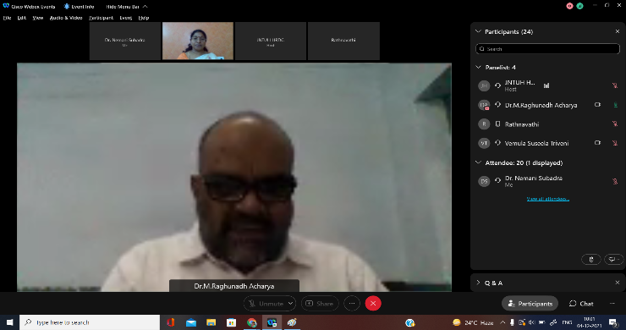 | 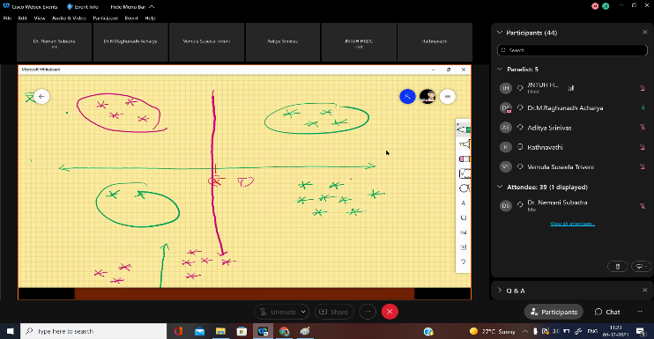
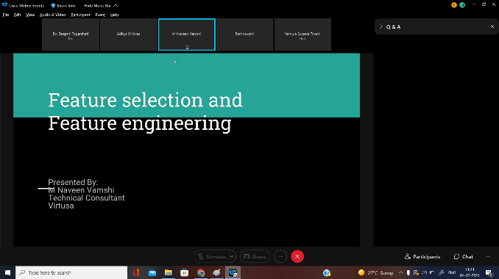 | 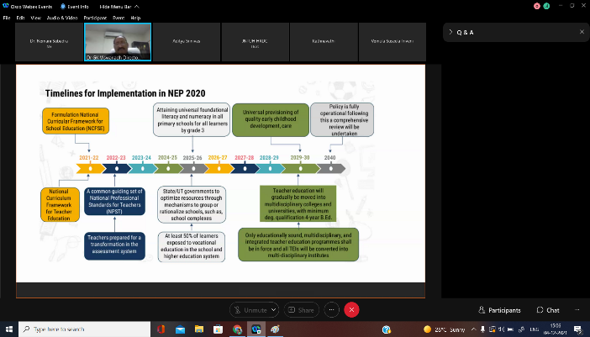

Valedictory
The concluding remarks were given by Dr. V.S.Triveni, STTP Coordinator, Geethanjali College of Engineering and Technology, Hyderabad. She explained the success of the STTP. on incredible number of participants 45, 12 Eminent Experts and 36 hrs of rigorous course training was the essence of this STTP. Participants updated their knowledge on statistical concepts, its role in Machine Learning and Data Science. The program had given a hands-on experience on various statistical concepts with the help of R programming tool to solve real world problems. She conveyed heartfelt thanks to the AICTE, UGC HRDC JNTUH for sponsoring this STTP.
Feedback
Most of participants rated that the STTP is very good /excellent on the whole. As per their feedback, course contents and sessions were excellent. They also felt happy for attending this Program and related hands-on sessions on R programming and expressed that they will utilize these concepts in future.
On the successful completion of this one-week STTP, E-certificates were distributed to the participants.

